Project Report
On

Vehicle Parking Management System

ACKNOWLEDGEMENT
I extend my deepest appreciation to my esteemed guide, Mr. XYZ for providing me with the possibility to complete this project with the right guidance and advice.

Special gratitude I give to my respected head of the division Mr.XYZ, for allowing me to use the facilities available and also help me to coordinate my project
Furthermore, I would also like to acknowledge with much appreciation the crucial role of faculty members on this occasion.

Last but not least, I would like to thank friends who help me to assemble the parts and gave a suggestion about the project.
.

----------------------

Abstract
Vehicle Parking Management System maintains a good record of vehicles check in and checkout time. Both two wheeler & four wheeler can be managed by this system and have different pricing system.
Vehicle parking management system that enables the time management and control of vehicles by using parking number.
The system that will track the entry and exit of vehicles, maintain a listing of vehicle within the parking lot, and determine the parking and it will also determine the cost of parking of vehicle.

Introduction
Introduction:-
Vehicle Parking Management system is a web-based technology that will manage the records of the incoming and outgoing vehicles in an parking house. It’s an easy for Admin to retrieve the data if the vehicle has been visited through number he can get that data. Vehicle parking management system is an automatic system which delivers data processing in very high speed in systematic manner.
In VPMS we use PHP and MySQL database. This is the project which keeps records of the vehicle which is going to park in the parking area. VPMS has two module admin and user.

ADMIN

Dashboard: In this sections, admin can briefly view the number of vehicle entries in a particular period.
Category: In this section, admin can manage category (add/update/delete).
Add Vehicle: In this section, admin add vehicle which is going to park.
Manage Vehicle: In this section, admin can manage incoming and outgoing vehicle and admin can also add parking charges and his/her remarks.
Reports: In this section admin can generate vehicle entries reports between two dates.
Search: In this section, admin can search a particular vehicle by parking number.
Admin can also update his profile, change the password and recover the password.

USERS

Dashboard: It is welcome page for an users.
View Vehicle: In this section, users view the details of vehicle parking which is parked by him/her.
Users can also update his profile, change the password and recover the password.

Purpose:-
The purpose of developing vehicle parking management system is to computerized the tradition way of parking. Another purpose for developing this application is to generate the report automatically.
Scope:-
In the modern age. Many people have vehicles. Vehicle is now a basic need. Every place is under the process of urbanization. There are many corporate offices and shopping centers etc. There are many recreational places where people used to go for refreshment. So, all these places need a parking space where people can park their vehicles safely and easily. Every parking area needs a system that records the detail of vehicles to give the facility. With the help of this system we can deliver a good service to customer who wants to park their vehicle into the any organization’s premises.

Requirement Specification

Hardware Configuration :

Client Side:
RAM RAMfgdfRA RAM | 512 MB
Hard disk | 10 GB
Processor | 1.0 GHz

Server side:
RAM | 1 GB
Hard disk | 20 GB
Processor | 2.0 GHz

Software Requirement:

Client Side:

Web Browser | Google Chrome or any compatible browser
Operating System | Windows or any equivalent OS

Server Side:

Web Server | APACHE
Server side Language | PHP5.6 or above version
Database Server | MYSQL
Web Browser | Google Chrome or any compatible browser
Operating System | Windows or any equivalent OS

APACHE
The Apache HTTP Server Project is an effort to develop and maintain an open-source HTTP server for modern operating systems including UNIX and Windows. The goal of this project is to provide a secure, efficient and extensible server that provides HTTP services in sync with the current HTTP standards.
The Apache HTTP Server ("httpd") was launched in 1995 and it has been the most popular web server on the Internet since April 1996. It has celebrated its 20th birthday as a project in February 2015.
PHP
- PHP stands for PHP: Hypertext Preprocessor.

- PHP is a server-side scripting language, like ASP.
- PHP scripts are executed on the server.
- PHP supports many databases (MYSQL, Informix, Oracle, Sybase, Solid, Generic ODBC, etc.).

- PHP is an open source software .
- PHP is free to download and use.

MYSQL

- MYSQL is a database server

- MYSQL is ideal for both small and large applications
- MYSQL supports standard SQL
- MYSQL compiles on a number of platforms
- MYSQL is free to download and use
- How to access MySQL: http://localhost/phpmyadmin

Analysis and Design
Analysis:
In present all visitors parking work done on the paper. The whole year visitor parking record is stored in the registers. We can’t generate reports as per our requirements because its take more time to calculate the visitors parking report.
Disadvantage of present system:
- Not user friendly: The present system not user friendly because data is not stored in structure and proper format.
- Manual Control: All report calculation is done manually so there is a chance of error.
- Lots of paper work: Visitors maintain in the register so lots of paper require storing details.
- Time consuming
Design Introduction:
Design is the first step in the development phase for any techniques and principles for the purpose of defining a device, a process or system in sufficient detail to permit its physical realization.Once the software requirements have been analyzed and specified the software design involves three technical activities - design, coding, implementation and testing that are required to build and verify the software.
The design activities are of main importance in this phase, because in this activity, decisions ultimately affecting the success of the software implementation and its ease of maintenance are made. These decisions have the final bearing upon reliability and maintainability of the system. Design is the only way to accurately translate the customer’s requirements into finished software or a system.
Design is the place where quality is fostered in development. Software design is a process through which requirements are translated into a representation of software. Software design is conducted in two steps. Preliminary design is concerned with the transformation of requirements into data

UML Diagrams:
Actor:
A coherent set of roles that users of use cases play when interacting with the use `cases.

Use case: A description of sequence of actions, including variants, that a system performs that yields an observable result of value of an actor.

UML stands for Unified Modeling Language. UML is a language for specifying, visualizing and documenting the system. This is the step while developing any product after analysis. The goal from this is to produce a model of the entities involved in the project which later need to be built. The representation of the entities that are to be used in the product being developed need to be designed.
USECASE DIAGRAMS:
Use case diagrams model behavior within a system and helps the developers understand of what the user require. The stick man represents what’s called an actor.
Use case diagram can be useful for getting an overall view of the system and clarifying who can do and more importantly what they can’t do.
Use case diagram consists of use cases and actors and shows the interaction between the use case and actors.
- The purpose is to show the interactions between the use case and actor.
- To represent the system requirements from user’s perspective.
- An actor could be the end-user of the system or an external system.

USECASE DIAGRAM: A Use case is a description of set of sequence of actions. Graphically it is rendered as an ellipse with solid line including only its name. Use case diagram is a behavioral diagram that shows a set of use cases and actors and their relationship. It is an association between the use cases and actors. An actor represents a real-world object. Primary Actor – Sender, Secondary Actor Receiver.

Use Case Diagrams:
Admin
Sign in

Add Vehicle Category
Dashboard
Manage Vehicle Category
(Update Details)

Ad

Add Vehicle

Manage Vehicle(Update Details)

View Reg Users

Generate Reports

Update Profile
Change Password

Password Recovery
Search
Users

Signup
Sign in

Dashboard
View Vehicle

Update Profile
Change Password

Password Recovery

Class Diagram:
A description of set of objects that share the same attributes operations, relationships, and semantics

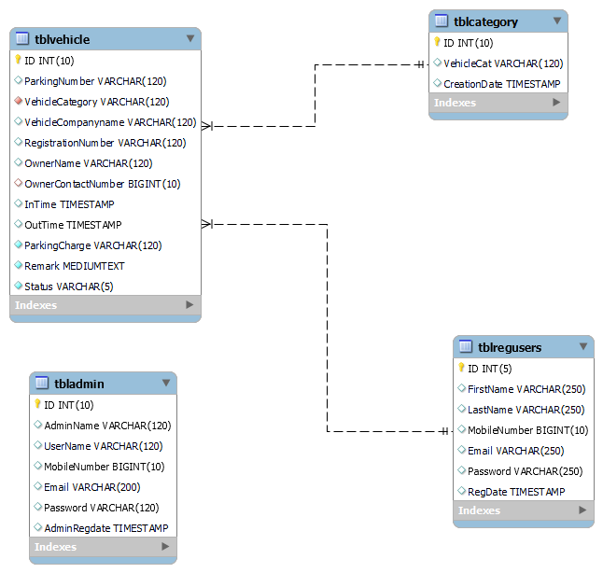

ER Diagram:
The Entity-Relationship (ER) model was originally proposed by Peter in 1976 [Chen76] as a way to unify the network and relational database views. Simply stated the ER model is a conceptual data model that views the real world as entities and relationships. A basic component of the model is the Entity-Relationship diagram which is used to visually represent data objects. Since Chen wrote his paper the model has been extended and today it is commonly used for database design for the database designer, the utility of the ER model is:
- It maps well to the relational model. The constructs used in the ER model can easily be transformed into relational tables.
- It is simple and easy to understand with a minimum of training. Therefore, the model can be used by the database designer to communicate the design to the end user.
- In addition, the model can be used as a design plan by the database developer to implement a data model in specific database management software.
ER Notation
There is no standard for representing data objects in ER diagrams. Each modeling methodology uses its own notation. The original notation used by Chen is widely used in academics texts and journals but rarely seen in either CASE tools or publications by non-academics. Today, there are a number of notations used; among the more common are Bachman, crow's foot, and IDEFIX.
All notational styles represent entities as rectangular boxes and relationships as lines connecting boxes. Each style uses a special set of symbols to represent the cardinality of a connection. The notation used in this document is from Martin. The symbols used for the basic ER constructs are:
- Entities are represented by labeled rectangles. The label is the name of the entity. Entity names should be singular nouns.
- Relationships are represented by a solid line connecting two entities. The name of the relationship is written above the line. Relationship names should be verbs
- Attributes, when included, are listed inside the entity rectangle. Attributes which are identifiers are underlined. Attribute names should be singular nouns.
- Cardinality of many is represented by a line ending in a crow's foot. If the crow's foot is omitted, the cardinality is one.
Existence is represented by placing a circle or a perpendicular bar on the line. Mandatory existence is shown by the bar (looks like a 1) next to the entity for an instance is required. Optional existence is shown by placing a circle next to the entity that is optional.

ER Diagram

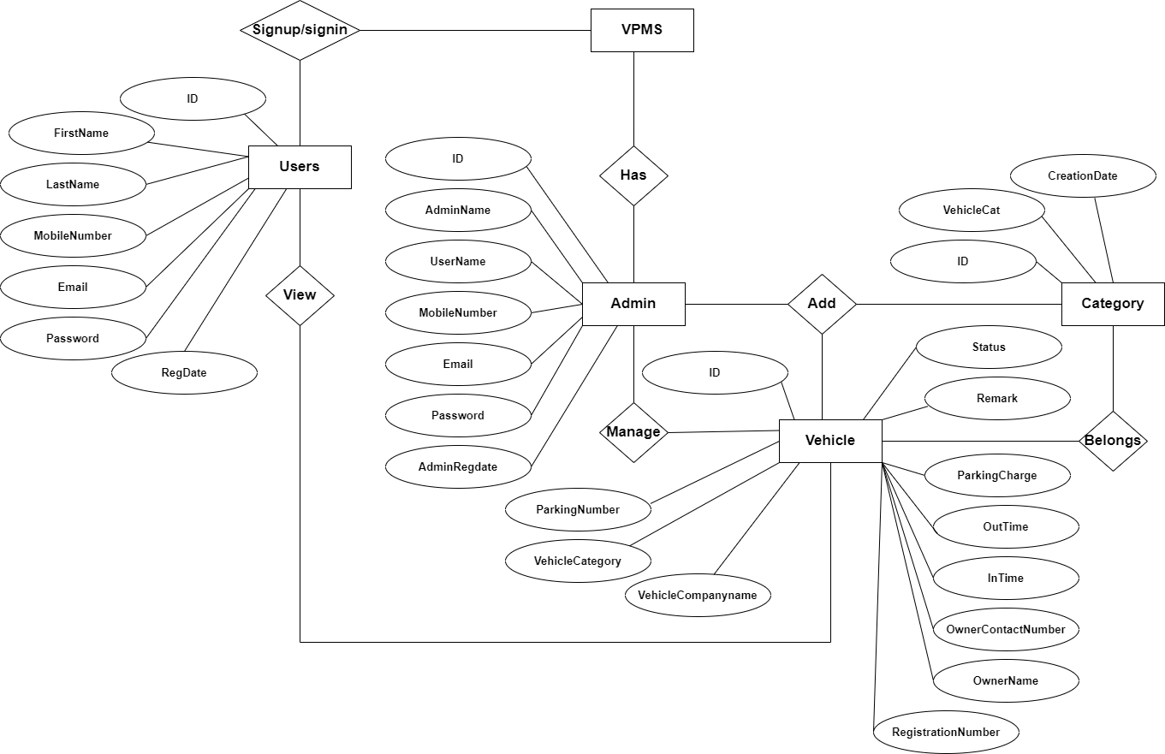

Data Flow Diagram

Data Flow Diagrams
A Data Flow Diagram (DFD) is a traditional visual representation of the information flows within a system. A neat and clear DFD can depict the right amount of the system requirement graphically. It can be manual, automated, or a combination of both.
It shows how data enters and leaves the system, what changes the information, and where data is stored.
The objective of a DFD is to show the scope and boundaries of a system as a whole. It may be used as a communication tool between a system analyst and any person who plays a part in the order that acts as a starting point for redesigning a system. The DFD is also called as a data flow graph or bubble chart.
The following observations about DFDs are essential:
- All names should be unique. This makes it easier to refer to elements in the DFD.
- Remember that DFD is not a flow chart. Arrows is a flow chart that represents the order of events; arrows in DFD represents flowing data. A DFD does not involve any order of events.
- Suppress logical decisions. If we ever have the urge to draw a diamond-shaped box in a DFD, suppress that urge! A diamond-shaped box is used in flow charts to represents decision points with multiple exists paths of which the only one is taken. This implies an ordering of events, which makes no sense in a DFD.
- Do not become bogged down with details. Defer error conditions and error handling until the end of the analysis.
Standard symbols for DFDs are derived from the electric circuit diagram analysis and are shown in fig:
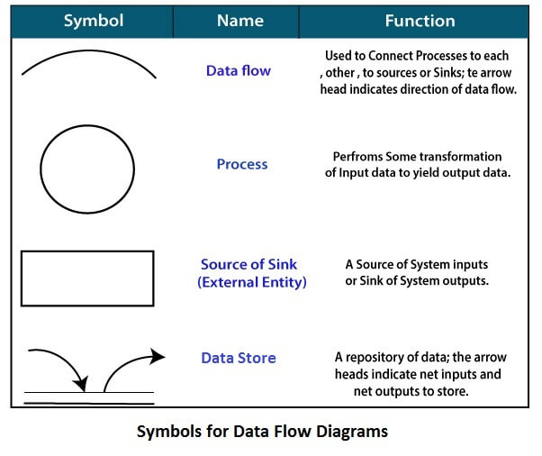
Circle: A circle (bubble) shows a process that transforms data inputs into data outputs.
Data Flow: A curved line shows the flow of data into or out of a process or data store.
Data Store: A set of parallel lines shows a place for the collection of data items. A data store indicates that the data is stored which can be used at a later stage or by the other processes in a different order. The data store can have an element or group of elements.
Source or Sink: Source or Sink is an external entity and acts as a source of system inputs or sink of system outputs.

Zero Level DFD

Password Management
Vehicle Category Management

Login Management

Outgoing Vehicle Management

User Management
Incoming Vehicle Management
VPMS

Vehicle Management
Administrator Management

First Level DFD
Incoming Vehicle Management
Login Management

Administrator Management
User Management

VPMS
Vehicle Management
Password Management

Generate Vehicle Report
Vehicle Category Management

Password Recovery Management
Outgoing Vehicle Management

Second Level DFD
Check Roles of access
Login to system
Admin

Manage Vehicle Category

Add Vehicle
Check Credential
Forgot Password

Manage incoming vehicle
Manage Modules

Manage outgoing vehicle

Generate vehicle report

Change Password
Update Profile
View Registered Users
Search vehicle

Login to system
Check Roles of access
Signup system
Users

ok

View Vehicle Parking Details

Check Credential
Manage Modules
Forgot Password

Update Profile

Change Password

MySQL Data Tables:
Admin Table:(Table name is admin)
This store admin personal and login details.
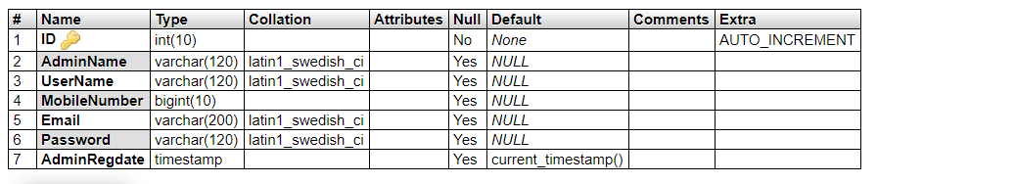
Category Table(Table name is tblcategory
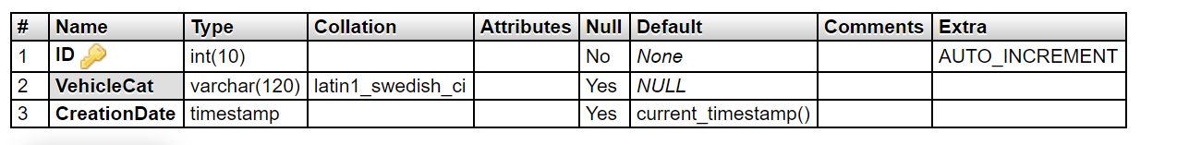

Vehicle Table: (Table name is vehicle)
This store the vehicle details and admin remark
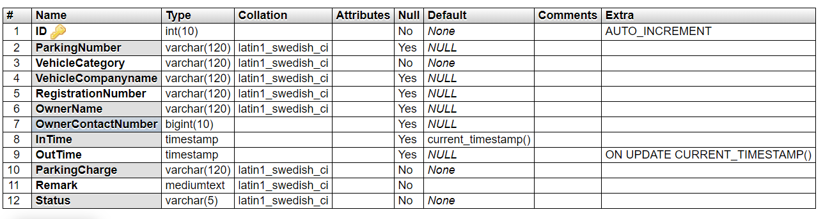
User Table: (Table name is tblregusers)
This table stores the details of registered users
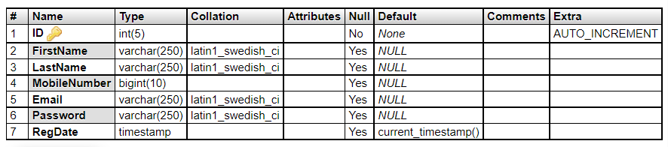

Implementation and System Testing
After all phase have been perfectly done, the system will be implemented to the server and the system can be used.

System Testing

The goal of the system testing process was to determine all faults in our project .The program was subjected to a set of test inputs and many explanations were made and based on these explanations it will be decided whether the program behaves as expected or not. Our Project went through two levels of testing

1. Unit testing
2. Integration testing

UNIT TESTING
Unit testing is commenced when a unit has been created and effectively reviewed .In order to test a single module we need to provide a complete environment i.e. besides the section we would require

- The procedures belonging to other units that the unit under test calls

- Non local data structures that module accesses

- A procedure to call the functions of the unit under test with appropriate parameters

1. Test for the admin module

- Testing admin login form-This form is used for log in of administrator of the system. In this form we enter the username and password if both are correct administration page will open otherwise if any of data is wrong it will get redirected back to the login page and again ask the details.

- Report Generation: admin can generate report from the main database.

INTEGRATION TESTING

In the Integration testing we test various combination of the project module by providing the input.
The primary objective is to test the module interfaces in order to confirm that no errors are occurring when one module invokes the other module.

EVALUATION
Project URL: http://localhost/vpms
Home Page
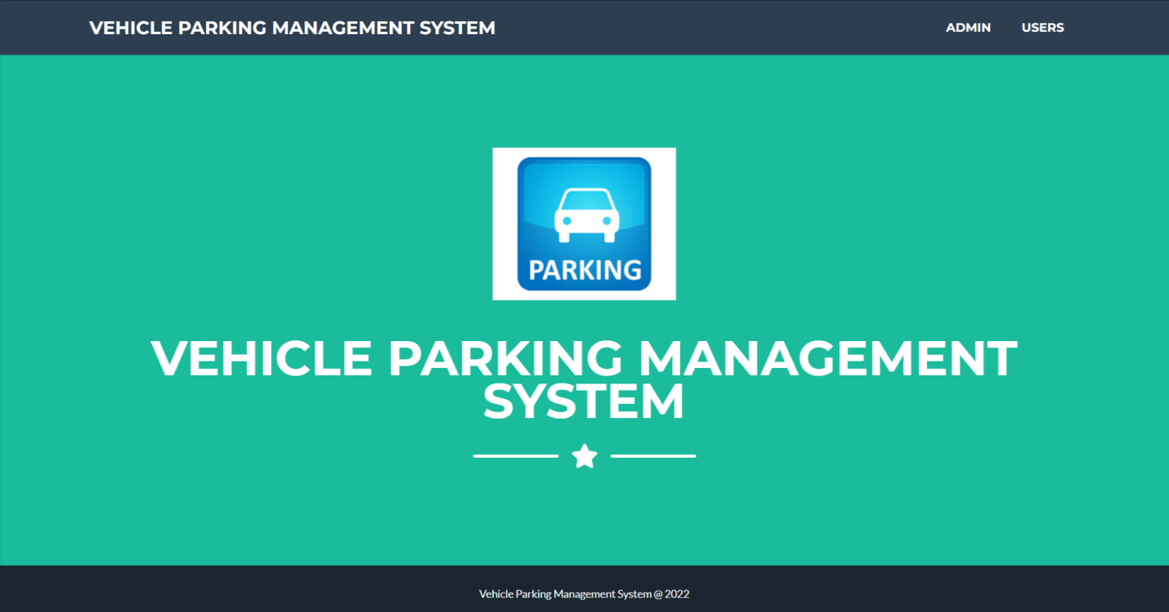

Admin Login Page
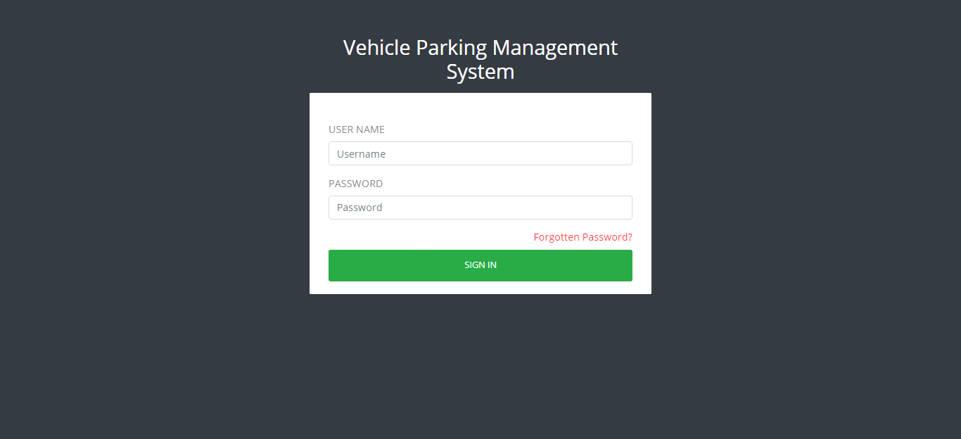

Dashboard
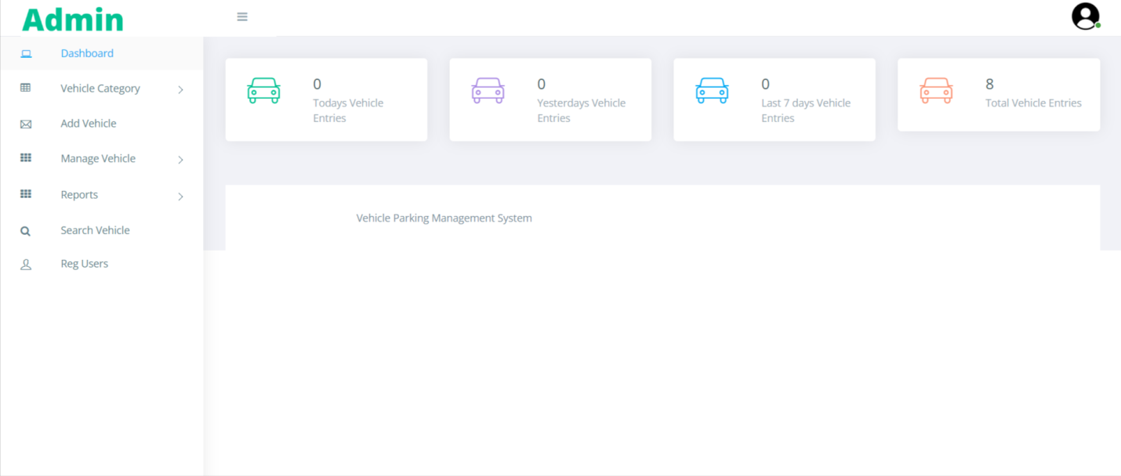

Profile
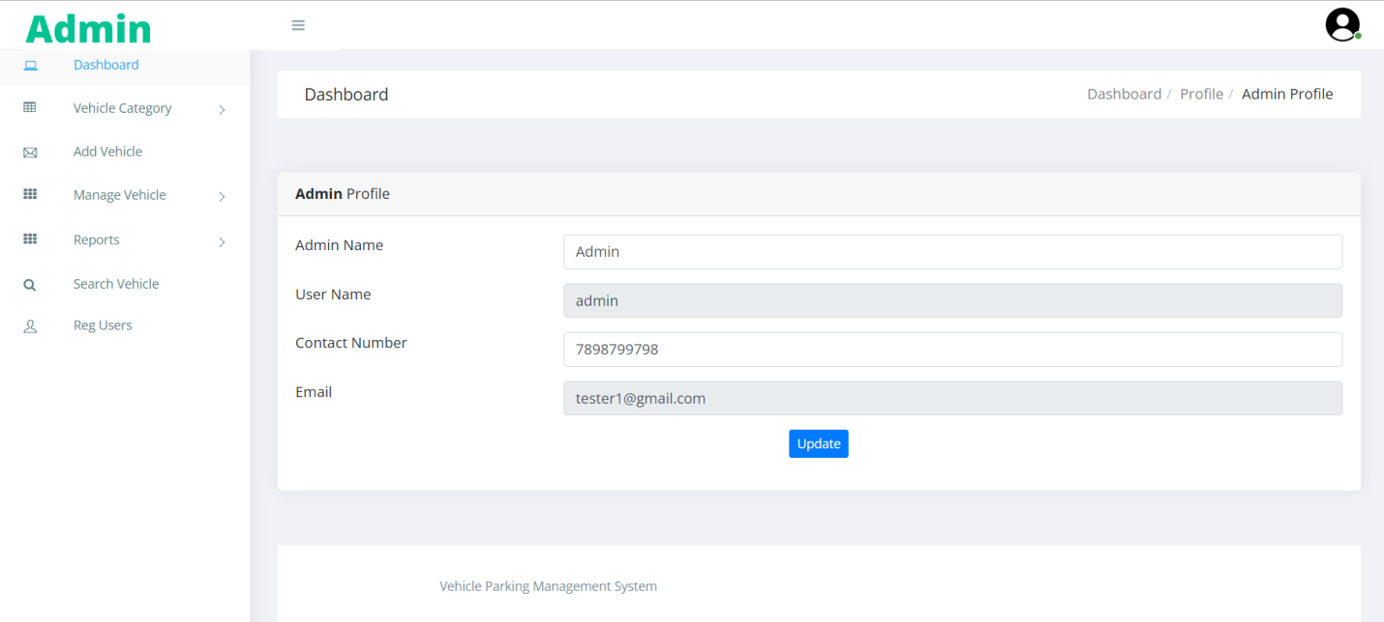

Change Password

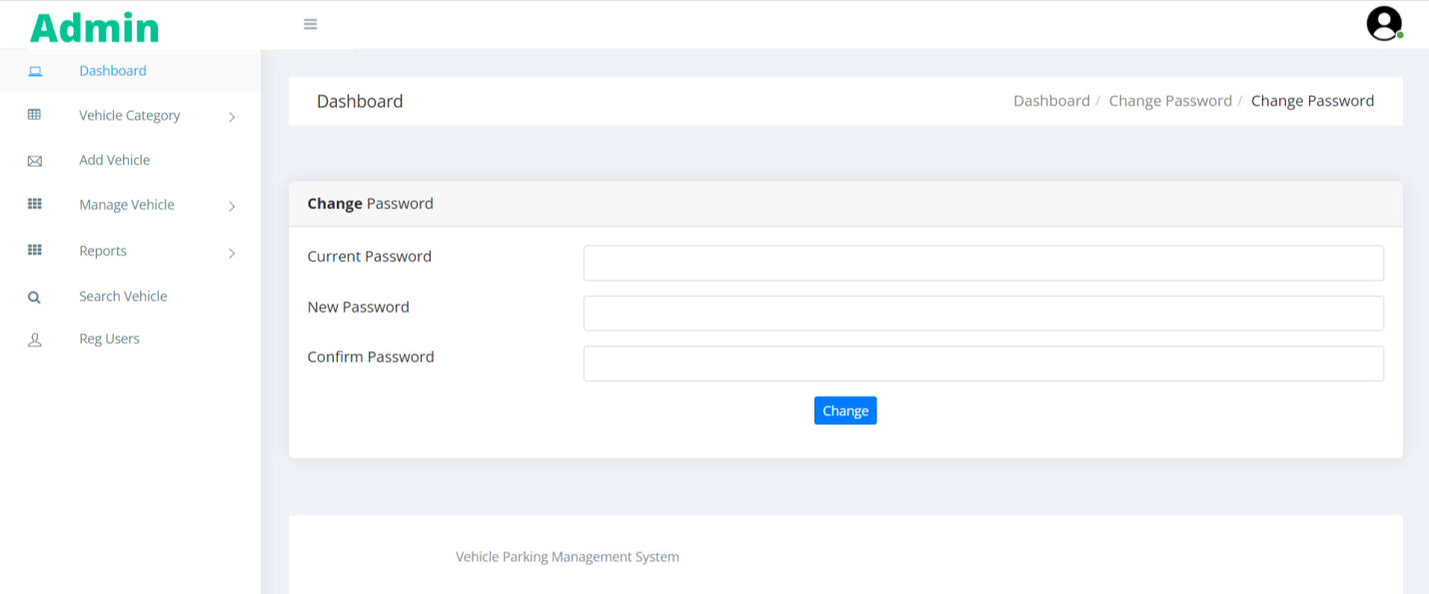

Add Category
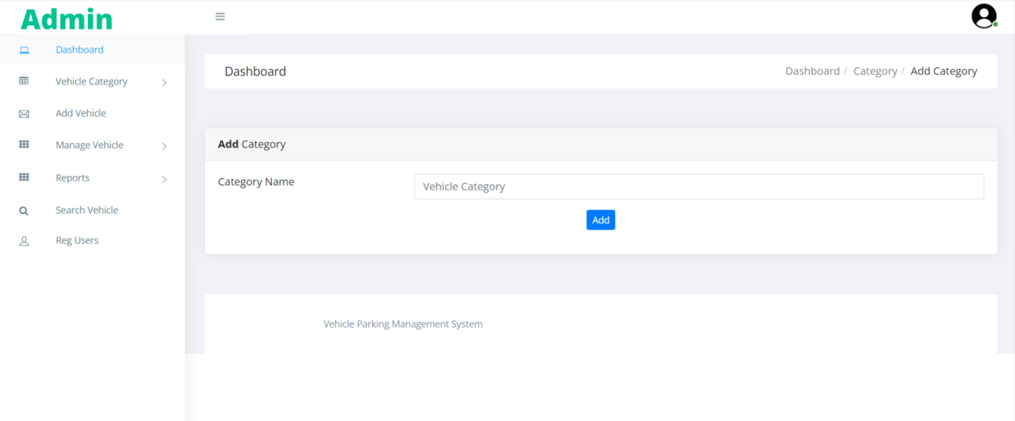

Manage Category
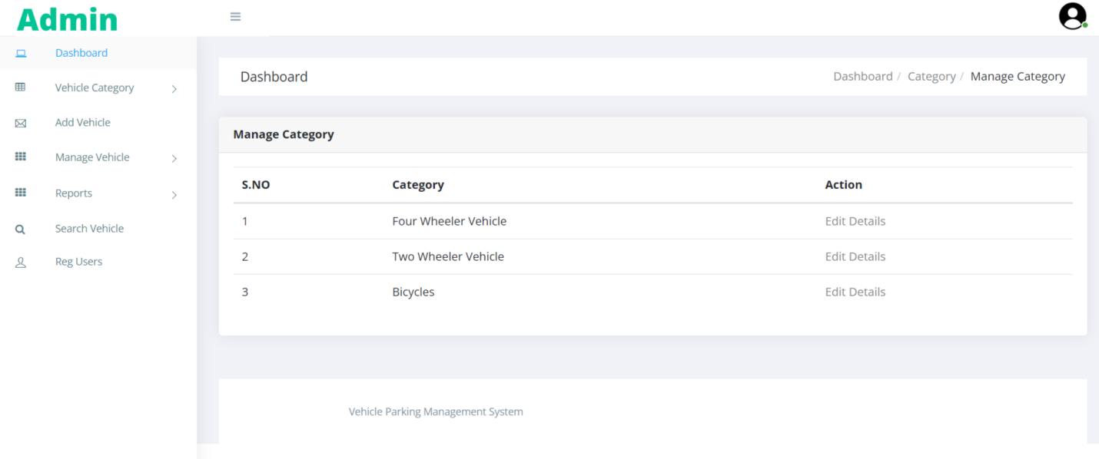

Update Category
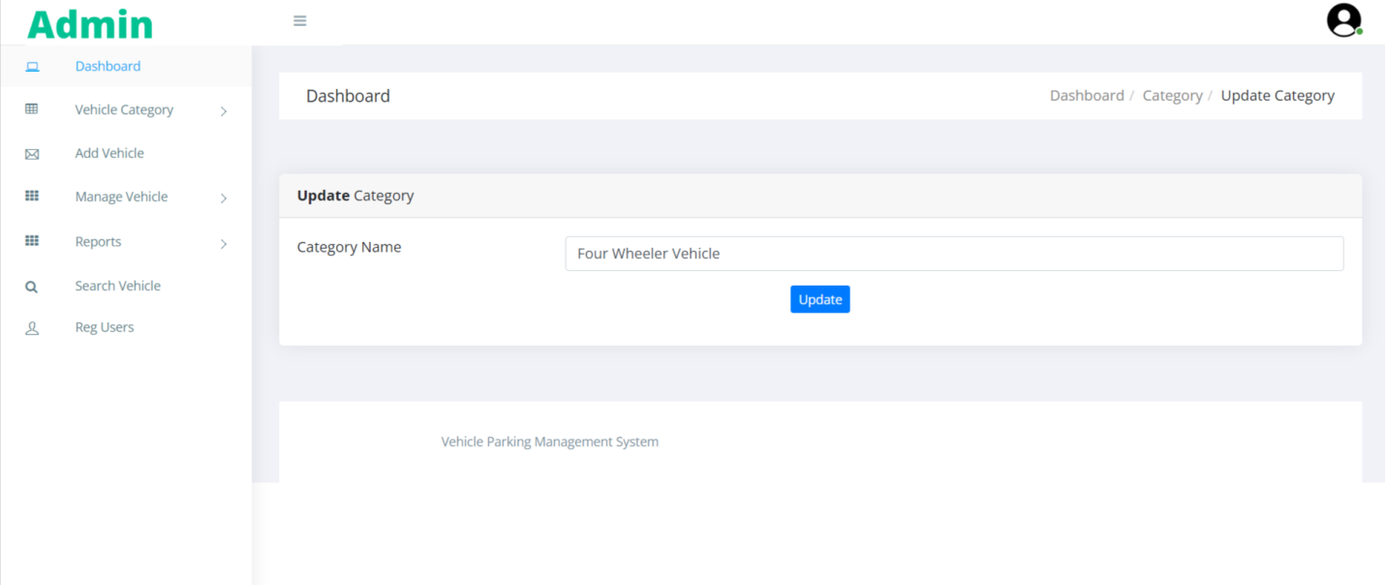

Add Vehicle

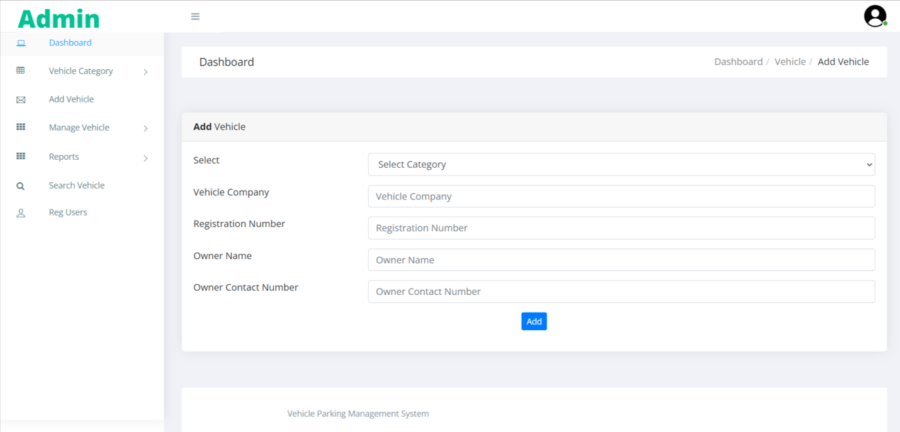

Manage Incoming Vehicle
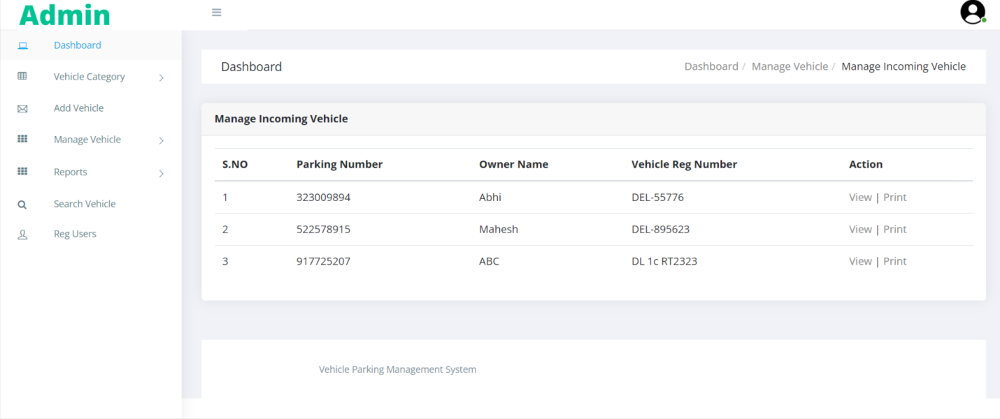

View Incoming Vehicle

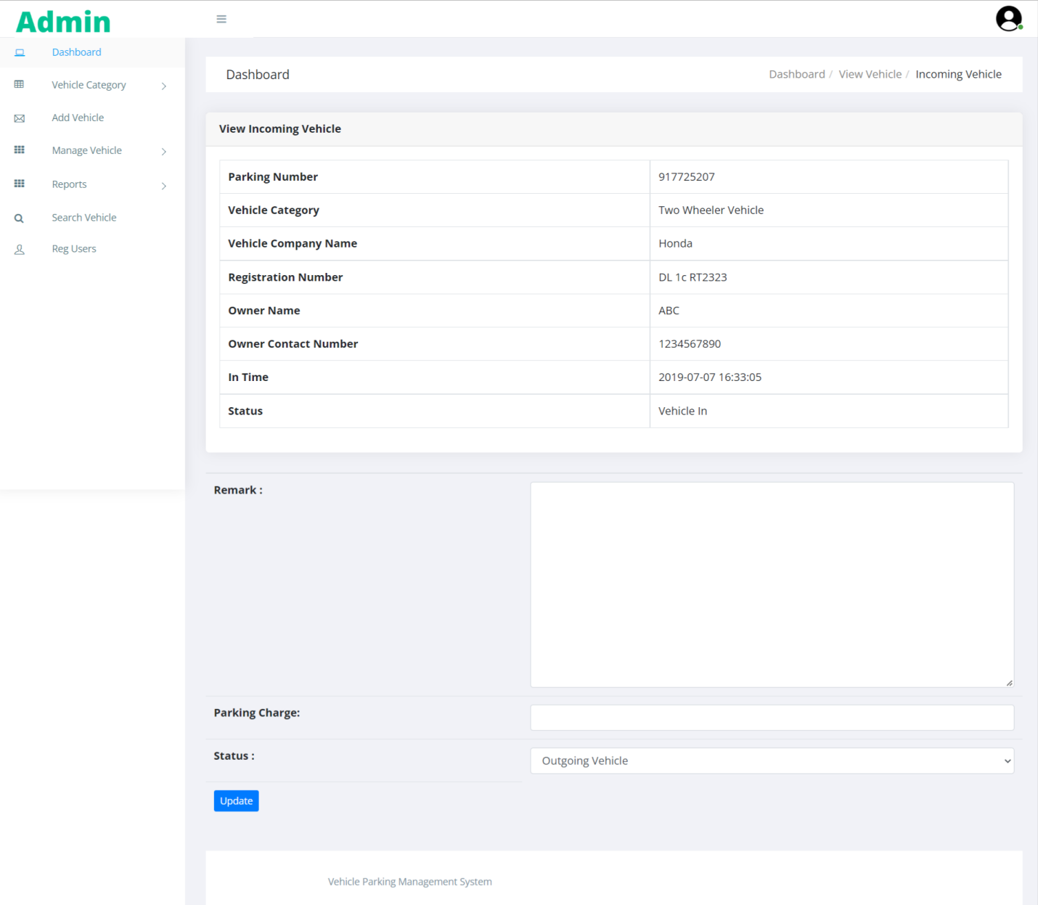

Parking Receipt
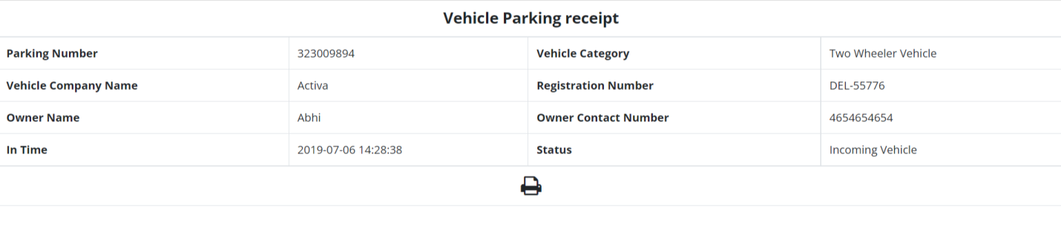

Manage Outgoing Vehicle

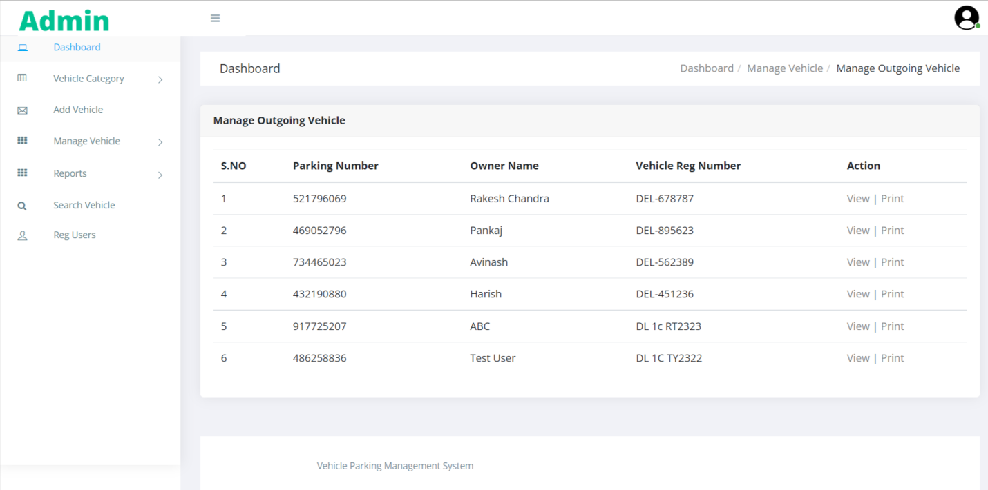

View Outgoing Vehicle

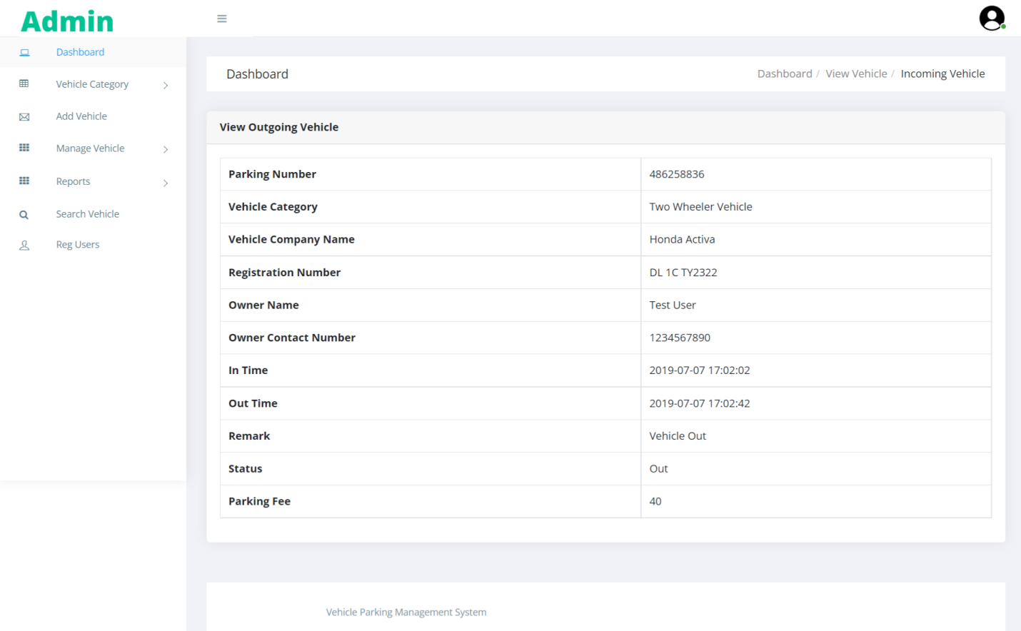

Vehicle Parking Receipt
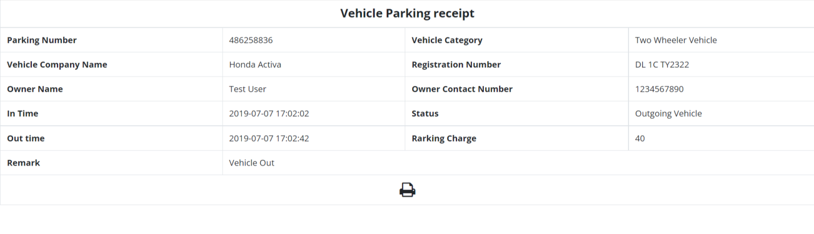

Between Dates Reports
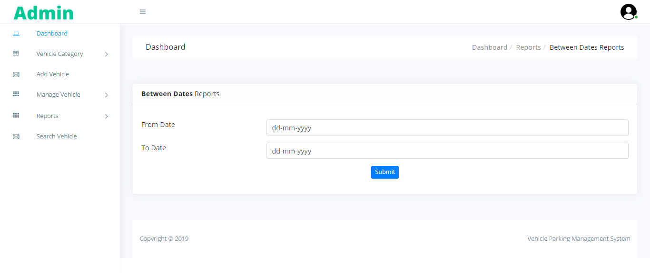
View Report
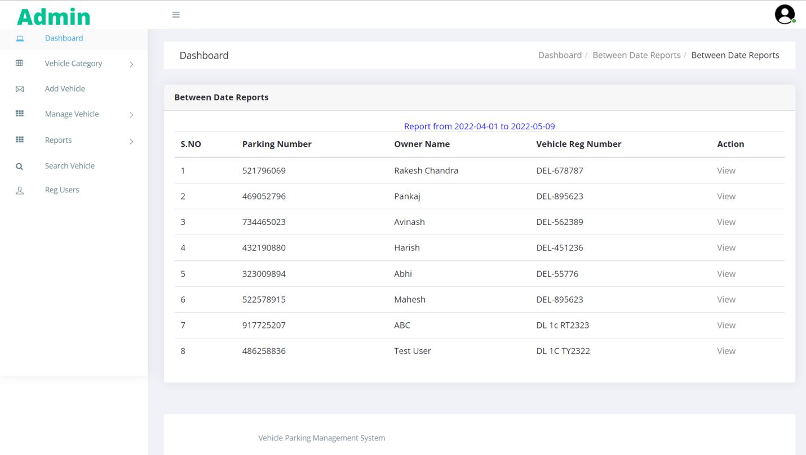

Search Vehicle
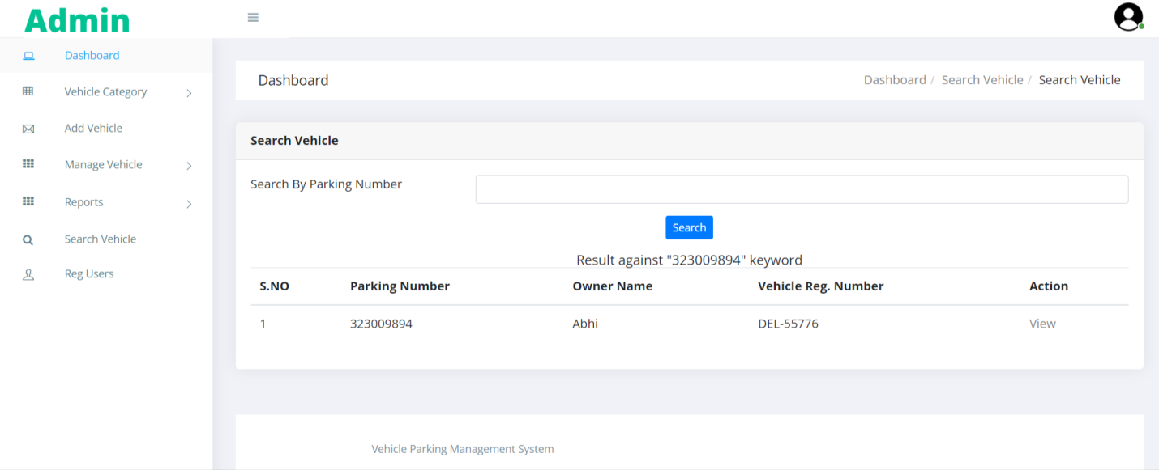

View Registered Users
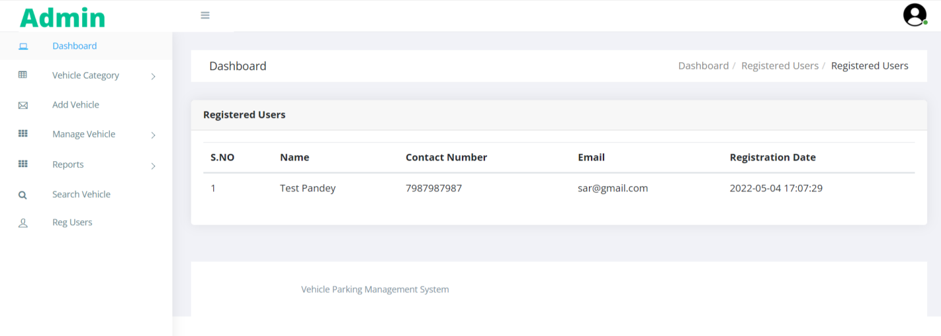

Forgot Password
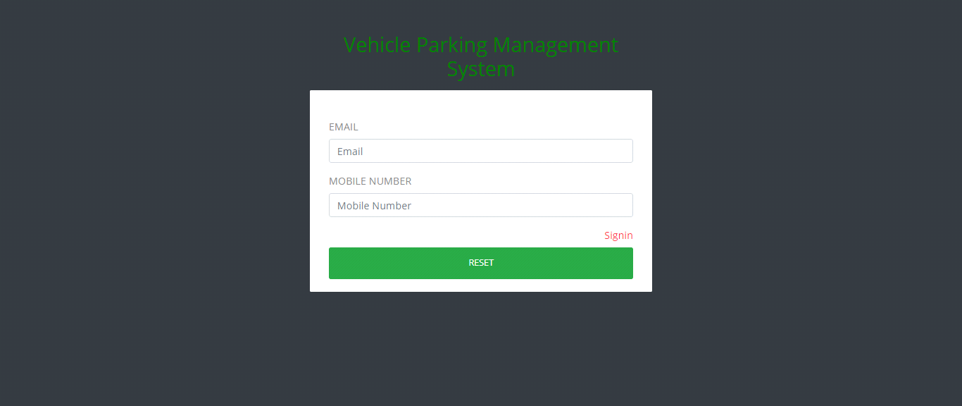

Reset Password

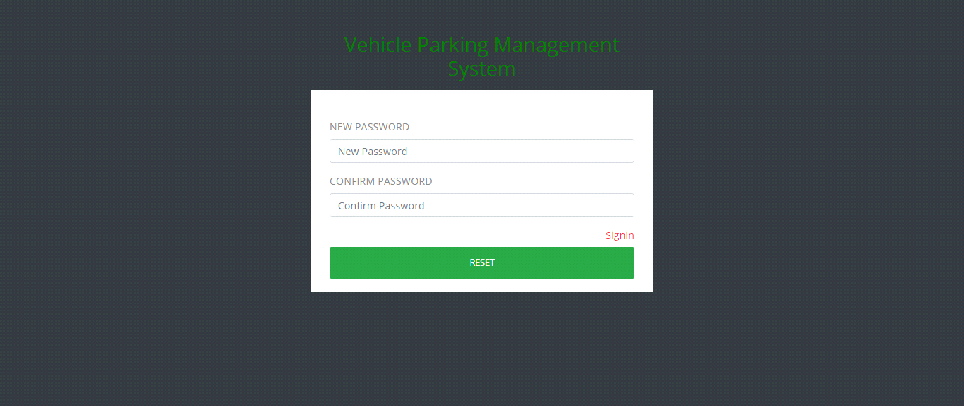

User Sign up
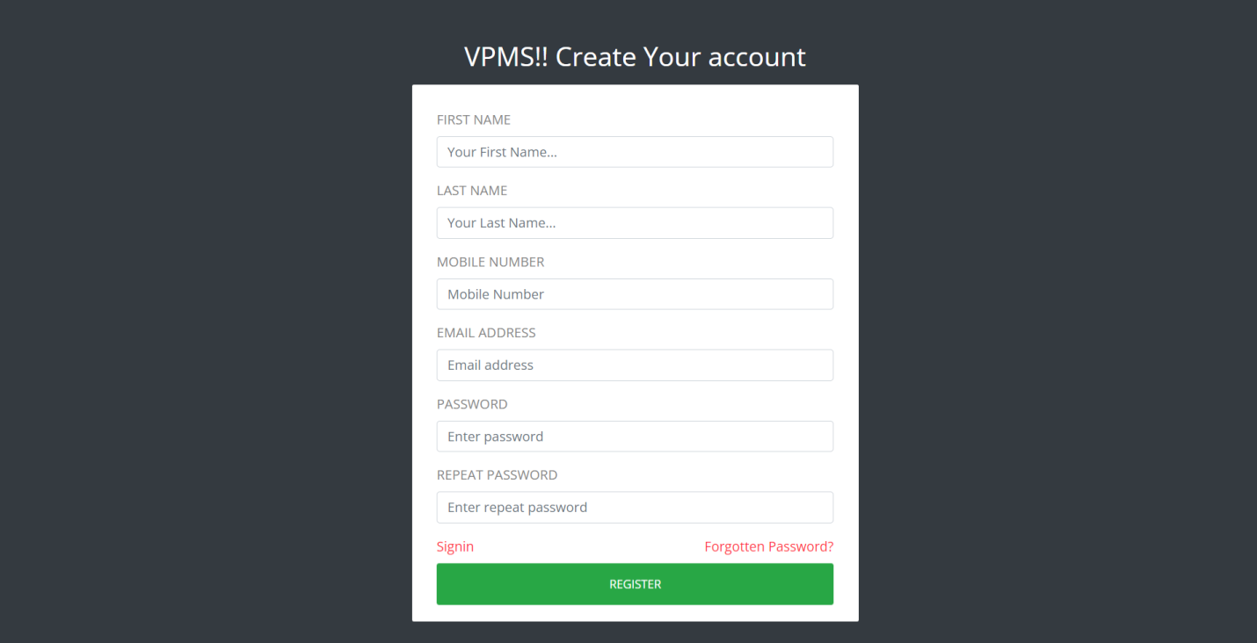

Sign in
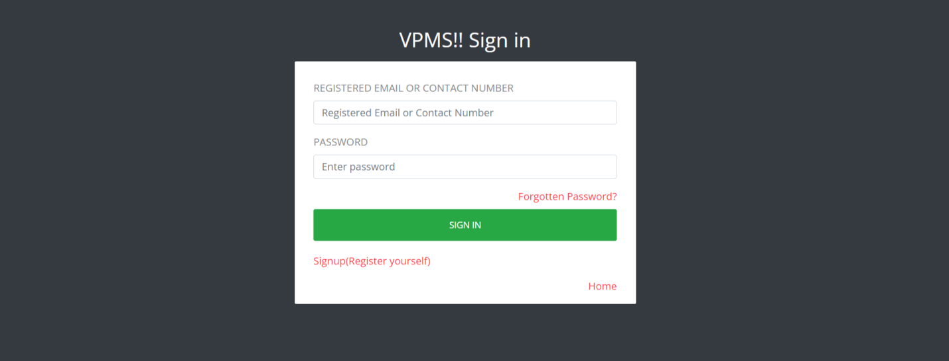

Dashboard
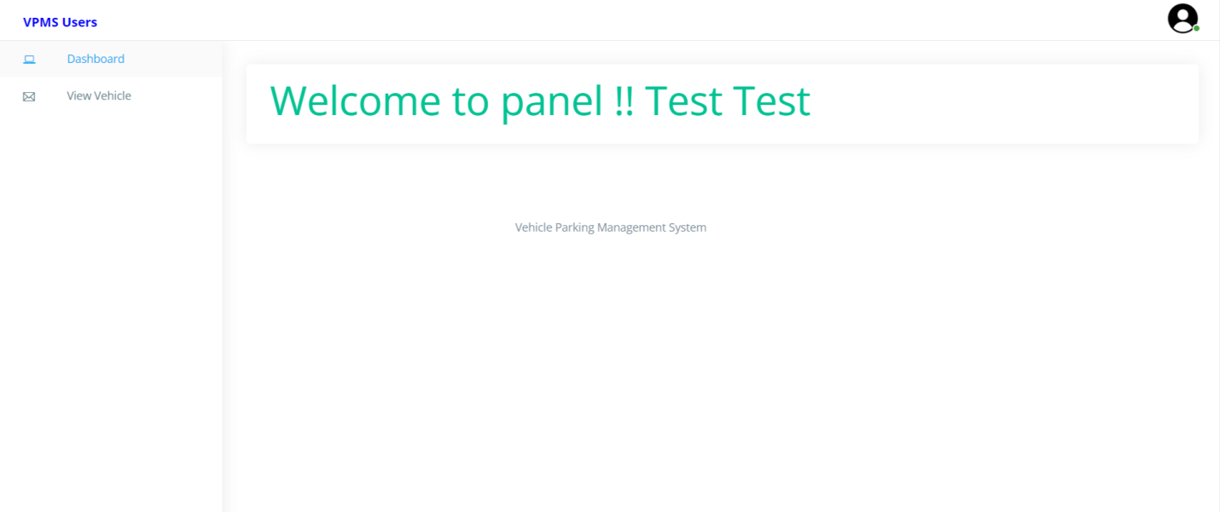
Profile

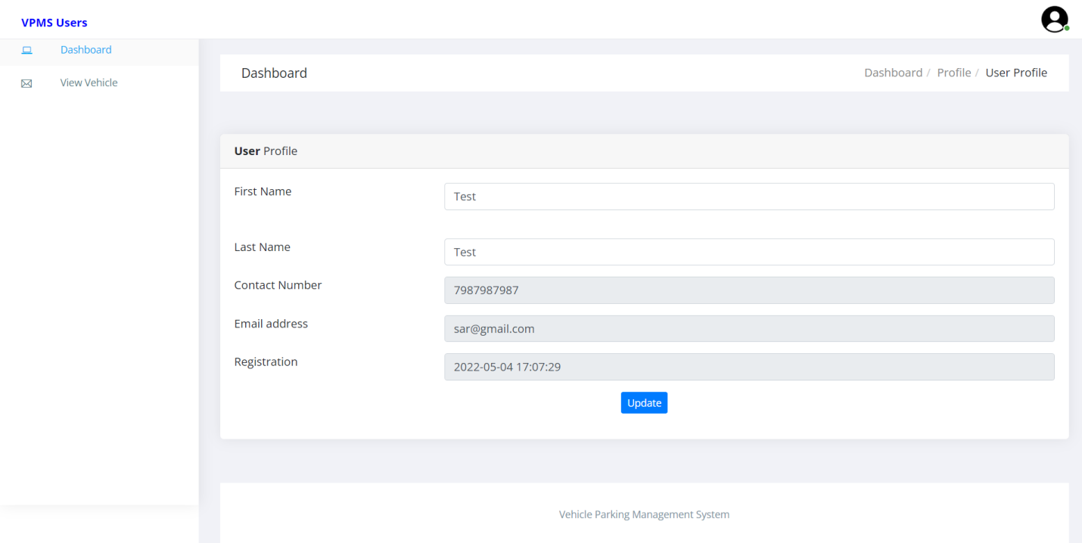

Change Password
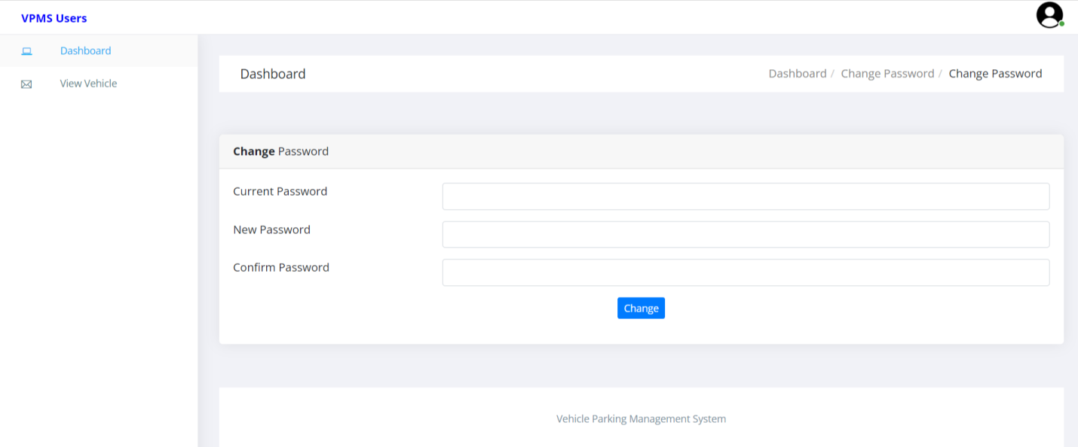

View Vehicle
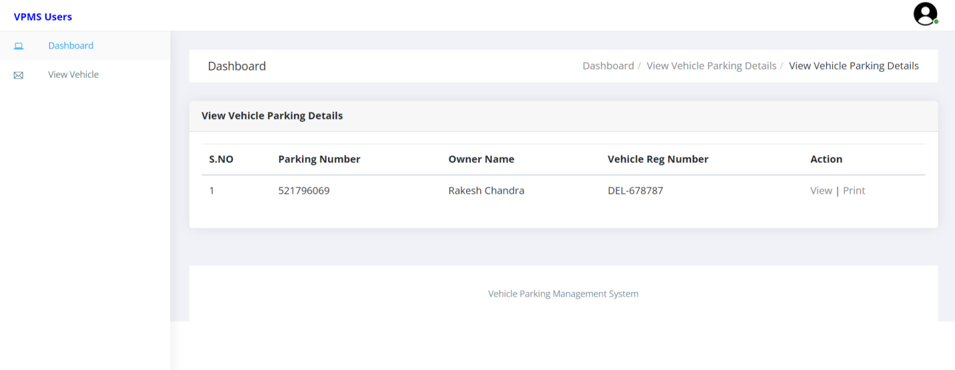

View Vehicle in details
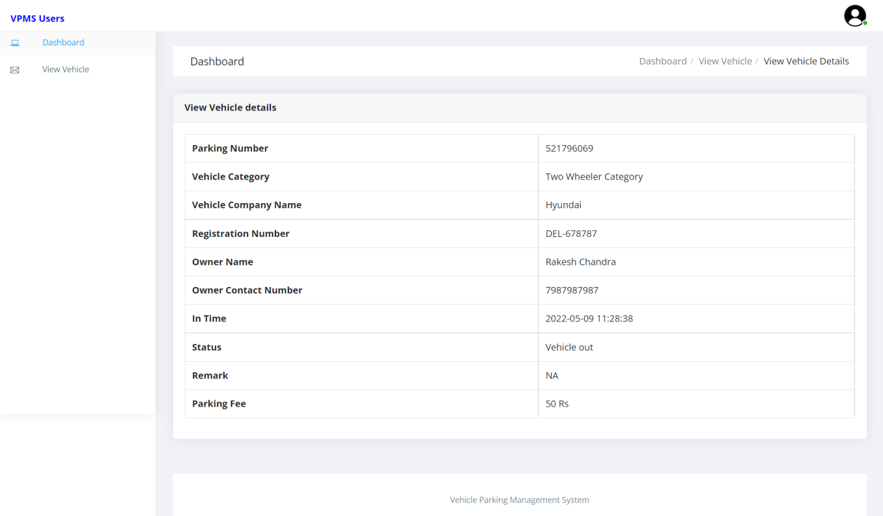

View Parking Receipt
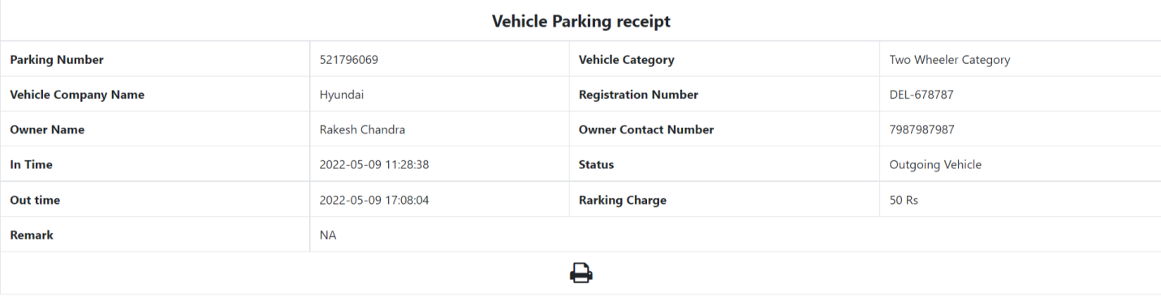

Forgot Password
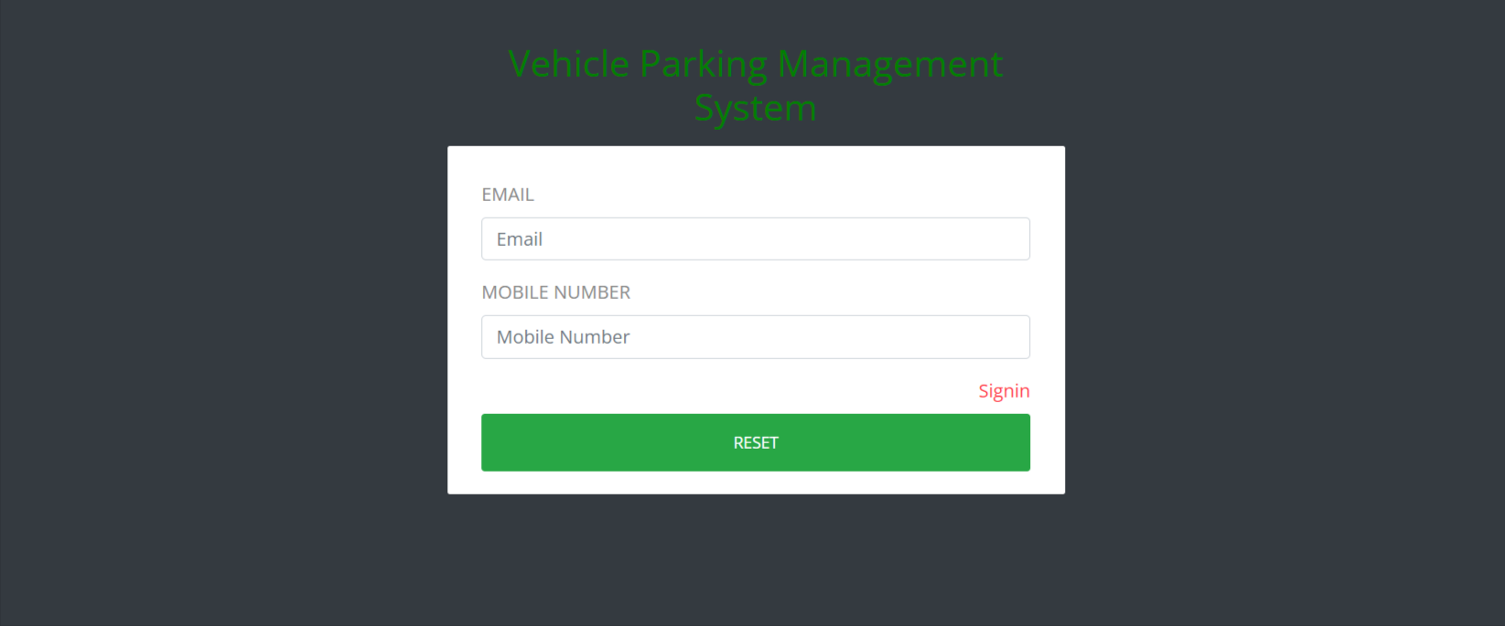

Reset Password
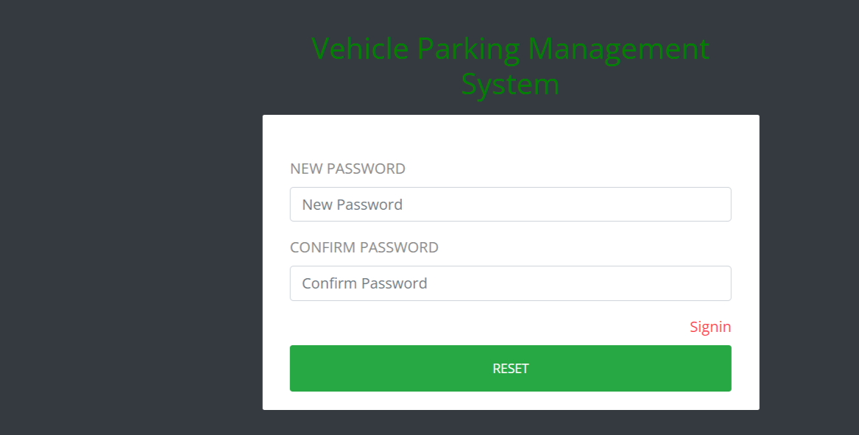

CONCLUSION:
This Application provides a computerized version of Vehicle Parking Management System which will benefit the parking premises.
It makes entire process online and can generate reports. It has a facility of staff’s login where staff can fill the visitor details and generate report.
The Application was designed in such a way that future changes can be done easily. The following conclusions can be deduced from the development of the project.
- Automation of the entire system improves the productivity.
- It provides a friendly graphical user interface which proves to be better when compared to the existing system.
- It gives appropriate access to the authorized users depending on their permissions.
- It effectively overcomes the delay in communications.
- Updating of information becomes so easier.
- System security, data security and reliability are the striking features.
- The System has adequate scope for modification in future if it is necessary.

References
For PHP
- https://www.w3schools.com/php/default.asp
- https://www.sitepoint.com/php/
- https://www.php.net/

For MySQL
- https://www.mysql.com/
- http://www.mysqltutorial.org

For XAMPP
- https://www.apachefriends.org/download.html

